A Major Project Report On “TOUR EASY”

Submitted in Partial Fulfillment of the Academic Requirement for the Award of Degree of

#### BACHELOR OF TECHNOLOGY

In

Computer Science & Engineering(AI&ML) Submitted

By

N.PRADEEP (22R01A66A4)

V.SAJEEV (22R01A66C3)

V.ARJUN (22R01A66C4)

Y.RAJA REDDY (22R01A66C9)

Under the esteemed guidance of

Mrs.A.Madhavi

(Assistant Professor)

Dept of (AIML)



#### CMR INSTITUTE OF TECHNOLOGY

(Approved by AICTE, Affiliated to JNTU, Hyderabad)Kandlakoya, Medchal Road, R.R. Dist., Hyderabad.

2023-2024

#### CMR INSTITUTE OF TECHNOLOGY (UGC AUTONOMOUS)

(Approved by AICTE, Affiliated to JNTU, Kukatpally, Hyderabad)

Kandlakoya,Medchal Road, Hyderabad.



CERTIFICATE

This is to certify that a Major Project entitled with: “ TOUR GUIDE” is being

Submitted By

N.PRADEEP (22R01A66A4)

V.SAJEEV (22R01A66C3)

V.ARJUN (22R01A66C4)

Y.RAJA REDDY (22R01A66C9)

In partial fulfillment of the requirement for award of the degree of B. Tech in CSE to the JNTUH,Hyderabad is a record of a bonafide work carried out under our guidance and supervision.

The results in this project have been verified and are found to be satisfactory. The results embodied in thiswork have not been submitted to have any other University for award of any other degree or diploma.

|  |  |  |
| --- | --- | --- |
| Signature of Guide | Signature of Coordinator | Signature of HOD |
| Mrs.A.Madhavi  (Asst.professor)  Dept of (AIML) | Mr. k.V Balamurali krishna  (Asst.professor)  Dept of CSE(AIML) | Prof.P.Pavan kumar  (Head of department)  Dept of CSE(AIML) |

#### EXTERNAL EXAMINER

ACKNOWLEDGEMENT

We are extremely grateful to Dr. M. Janga Reddy, Director, Dr.G.Madhu sudhana rao, Principal and Mr.P.Pavan Kumar, Head of Department, Dept of Computer Science and Engineering(AI&ML), CMR Institute of Technology for their inspiration and valuable guidance during entire duration.

We are extremely thankful to Major Project Coordinator and internal guide Mr. Venkata Bala Murali Krishna(Assistant Professor),Dept of Computer Science and Engineering,

Mrs.A.Madhavi(Assistant Professor),Dept of AIML CMR Institute of Technology for their constant guidance, encouragement and moral support throughout the project.

We will be failing in duty if we do not acknowledge with grateful thanks to the authors of the references and other literatures referred in this Project.

We express our thanks to all staff members and friends for all the help and coordination extended in bringing out this Project successfully in time.

Finally, we are very much thankful to our parents and relatives who guided directly or indirectly for every step towards success.

N.PRADEEP (22R01A66A4)

V.SAJEEV (22R01A66C3)

V.ARJUN (22R01A66C4)

Y.RAJA REDDY (22R01A66C9)

ABSTRACT

The tour guide application embodies a multifaceted approach, integrating various features to cater to diverse user preference and travel requirements. Though an intuitive user interface, travellers can seamlessly navigate the application, accessing a plethora of functionalities designed to enhance the exploration endeavors. Key features include interactive maps, real-time location tracking, comprehensive destination insights curated by algorithms based on user preferences, historical data and current trends.

Further more, the tour guide application employes machine learning algorithms to adapt and refine its recommendations based on user feedback, ensuring continuous improvement and personalized experiences for each traveller. Additionally, the application offers multi-lingual support, enabling seamless communication for international travellers across different cultural and linguistic backgrounds.

One of the hallmark features of tour guide application is its conversational interface, allowing travellers to interact with the application in the natural language. By leveraging state of the art NLP models, the application can understand user queries, provide contextual responses, and engage in meaningful conversational, simulating the experience of having a knowledgeble tour at the travellers disposal throughout their journey.

Through extensive testing and iterative development, the tour guide application demonstrates promising results in enhancing the overall tourism experience. By leveraging technologies, the application empowers travellers to explore destinations at their own pace, discover hidden gems, and gain deeper insights into local culture, history, and attractions.

TABLE OF CONTENTS

|  |  |
| --- | --- |
| ACKNOWLEDGEMENT | I |
| ABSTRACT | II |
| LIST OF CONTENTS | III |
| LIST OF FIGURES | IV |
| LIST OF TABLES | V |
| LIST OF SCREENSHOTS | VI |
| 1. INTRODUCTION | 5 |
| 2. LITERATURE SURVEY |  |
| 3. SYSTEM ANALYSIS | 10 |
| 4. SYSTEM STUDY | 12 |
| 5. HARDWARE AND SOFTWARE REQUIREMENTS | 14 |
| 6. REQUIREMENT ANALYSIS | 16 |

1. MODULES DESCRIPTION 14
2. DIAGRAMS 15
   1. DATA FLOW DIAGRAM 16
   2. UML DIAGRAM 17
   3. USE CASE 18
   4. CLASS DIAGRAM 19
   5. SEQUENCE DIAGRAM 20
   6. ACTIVITY DIAGRAM 21
3. IMPLEMENTATION 22
4. INPUT AND OUTPUT DESIGN 31
   1. INPUT DESIGN 31
   2. OBJECTIVES 31
   3. OUTPUT DESIGN 31
5. SCREENSHOTS 32
6. SYSTEM TESTING 37
   1. TYPES OF TESTING 37
      1. UNIT TESTING 37
      2. INTEGRATION TESTING 37
      3. FUNCTIONAL TEST 38
      4. SYSTEM TEST 38
   2. WHITE BOX TESTING 38
      1. BLACK BOX TESTING 39
      2. UNIT TESTING 39
   3. TEST STRATEGY AND APPROACH 39
   4. TEST OBJECTIVES 39
   5. FEATURES TO BE TESTED 39
   6. INTEGRATION TESTING 39
   7. TEST RESULTS 40
   8. ACCEPTANCE TESTING 40
   9. TEST RESULTS 40
   10. SAMPLE TEST CASES 40
7. CONCLUSION 44
8. REFERENCES 45

# LIST OF FIGURES

|  |  |  |
| --- | --- | --- |
| FIGURE NO. | FIGURE PARTICULARS | PAGE NO. |
| 8 | System Architecture | 15 |
| 8.1 | Data Flow Diagram | 17 |
| 8.3 | Use Case Diagram | 19 |
| 8.4 | Class Diagram | 20 |
| 8.5 | Sequence Diagram | 20 |
| 8.6 | Activity Diagram | 21 |

1. **INTRODUCTION**

## OVERVIEW OF THE PROJECT-

Certainly! A tour guide project typically involves creating a system that uses technology to assist or enhance the experience of tourists during their visits to various destinations. Here's an overview of what such a project might entail:

1. **Objective:** The main objective of the project is to provide tourists with user friendly website that offers information, directions, and recommendations tailored to their interests and preferences.

### Features:

**Interactive Map:** The system may include an interactive map that displays points of interest, attractions, restaurants, and other relevant locations.

**Personalized Recommendations**: The system can offer personalized recommendations based on the tourist's interests, such as historical sites, cultural events, or dining preferences.

**Multilingual Support**: To cater to a diverse range of visitors, the system may support multiple languages with google translate feature and textual information.

**Navigation Assistance**: Provide turn-by-turn directions and navigation assistance to help tourists navigate to different locations efficiently.

**Feedback and Reviews**: Allow tourists to provide feedback and reviews about their experiences, which can help improve the system and provide valuable insights for future visitors.

### Technology Stack:

**Mobile Application**: Develop a mobile application for tourists to access the automation tour guide features conveniently on their smartphones.

**GPS and Location Services**: Utilize GPS and location services to track the tourist's location and provide relevant information about nearby attractions.

**Content Management System (CMS):** Implement a CMS to manage and update the content, including descriptions, images, and audio files for the tour guide.

**Cloud Services**: Use cloud services for storage, processing, and scalability, especially for handling large amounts of data and user interactions.

-

**4.Implementation**:

**Research and Planning:** Conduct research on the target destinations, tourist preferences, and existing tourism infrastructure to inform the design and development process.

**Development:** Design and develop the mobile application, backend infrastructure, and content management system, integrating various features and technologies.

**Testing and Iteration:** Test the system thoroughly to ensure functionality, usability, and reliability. Gather feedback from real users and iterate on the design based on their input.

**Deployment:** Deploy the tour guide system to the target destinations, ensuring compatibility with local infrastructure and providing support for tourists during their visits.

Overall, A tour guide project aims to leverage technology to enhance the tourist experience, making it more informative, engaging, and convenient for visitors to explore and enjoy their chosen destinations.

## EXISTING SYSTEMS-

Sure, there are several existing systems that utilize various technology to provide tour guide services. Here are a few examples:

Tourist guide websites, while generally useful, often face several drawbacks. Here are some examples, each associated with a specific website:

1. **TripAdvisor:**

**Information Overload:** Users can find it overwhelming to sift through the vast amount of reviews and opinions.

**Fake Reviews:** The presence of fake or biased reviews can mislead users.

**Outdated Information**: Some listings may not be regularly updated, leading to outdated information about attractions or services.

2. **Lonely Planet:**

**Paywalls**: Some of the more detailed and useful content is behind a paywall, limiting access for users.

**Navigation Issues**: Users sometimes find the website's navigation complex and unintuitive.

**Limited Real-Time Updates:** Information may not always be updated in real-time, affecting the accuracy of travel advice.

3. **Booking.com**:

**Hidden Costs:** The final price may include hidden fees or taxes that are not initially visible.

**Overwhelming Choices**: The vast number of options can be overwhelming, making it difficult for users to make decisions.

**Aggressive Marketing:** Persistent pop-ups and marketing tactics can detract from the user experience.

**4. Expedia:**

**Customer Service:** Users often report issues with customer service, especially regarding cancellations and refunds.

**Misleading Deals:** Some deals may appear better than they actually are due to fine print or exclusions.

**Complex Booking Process:** The booking process can be complicated, leading to user frustration.

5. **Yelp:**

**Bias Toward Negative Reviews**: The platform can have a bias toward negative reviews, which might not represent the overall quality of a service.

**Review Manipulation**: Businesses sometimes manipulate reviews to improve their ratings.

**User Experience Issues**: The mobile app and website can be slow and cumbersome to use.

6. **Google Travel**:

**Privacy Concerns**: Extensive tracking of user data can raise privacy issues.

Algorithm Bias: The recommendations are heavily algorithm-driven, which may not always reflect the best options for every user.

**Limited Customization**: Users have limited ability to customize their travel plans within the platform.

These drawbacks highlight the importance of continuously improving user experience, ensuring data accuracy, and maintaining transparent business practices to build trust and reliability.

## 1.3PROPOSED SYSTEMS-

To address the drawbacks of existing tourist guide websites, a proposed system can be designed with updated reviews, nearby hotel recommendations, and enhanced user experience. Here’s a detailed outline of such a system:

**Proposed System**: TravelEasy

Key Features

1. Real-Time Updated Reviews:

**Verified Reviews**: Implement a verification process to ensure reviews are authentic and written by actual visitors.

**Review Moderation**: Use AI to filter out fake or spam reviews and maintain the quality of user-generated content.

**Recent Reviews Highlight**: Prioritize displaying the most recent reviews to ensure users get up-to-date information.

**2. Nearby Hotel Recommendations**:

Location-Based Suggestions: Use geolocation to recommend hotels close to the user's current location or the destination they are viewing.

**Real-Time Availability**: Integrate with hotel booking systems to show real-time availability and pricing.

**User Ratings and Reviews**: Display hotel ratings and reviews from verified guests to help users make informed decisions.

**3. Enhanced User Experience**:

Intuitive Interface: Design a user-friendly and intuitive interface for easy navigation and quick access to information.

Personalized Recommendations: Use machine learning algorithms to provide personalized travel and accommodation suggestions based on user preferences and past behavior.

Interactive Maps: Integrate interactive maps showing attractions, hotels, restaurants, and other points of interest.

**4. Comprehensive Information**:

Detailed Listings: Provide comprehensive details about attractions, including photos, descriptions, entry fees, and operating hours.

User-Generated Content: Allow users to upload photos and videos of their experiences to enrich the content.

Travel Guides and Itineraries: Offer curated travel guides and itineraries for various destinations.

**5. Mobile App**:

Offline Access: Allow users to download travel guides and maps for offline use.

Push Notifications: Send notifications for important updates, such as booking confirmations, nearby attractions, and special offers.

**6. Social Integration**:

Social Media Sharing: Enable users to share their travel experiences and reviews on social media platforms.

Community Features: Create a community section where travelers can interact, ask questions, and share tips.

Implementation Strategy

**1. Data Aggregation:**

Partner with existing travel review sites, hotel booking platforms, and local tourism boards to aggregate data.

Use APIs to pull real-time data on hotel availability, pricing, and user reviews.

**3. User Engagement**:

Encourage users to leave reviews by offering incentives such as discounts, loyalty points, or special badges.

Facilitate user interaction and feedback to continually improve the platform based on user needs.

**4. Quality Assurance**:

- Regularly update the database to ensure all information is current and accurate.

- Conduct periodic audits of reviews and content to maintain quality and reliability.

**5. Security and Privacy**:

- Ensure robust data security measures to protect user information.

- Provide clear privacy policies and options for users to control their data.

**Benefits**

Trust and Reliability: Enhanced verification and moderation processes build user trust.

Convenience: Real-time data and personalized recommendations make trip planning easier and more enjoyable.

Engagement: Social and community features foster user engagement and create a vibrant travel community.

Accessibility: Offline access and a user-friendly interface ensure information is readily available to all users.

By addressing the drawbacks of existing systems and focusing on user-centric features, TravelEasy aims to provide a comprehensive, reliable, and enjoyable travel planning experience.

## LITERATURE SURVEY

Literature Survey on Tour Guides

### Introduction

Traveling is an enriching experience that broadens horizons and creates lasting memories. However, the process of planning a trip can often be overwhelming and time-consuming. To address this challenge, our project presents an innovative tourist guide website designed to simplify and enhance the travel experience for users. This website aims to serve as a comprehensive resource for travelers, providing all the necessary information and tools in one convenient platform.

### 1. Technologies in Tour Guides

Natural Language Processing (NLP): NLP enables tour guides to understand and respond to user queries in natural language, making interactions more intuitive. Studies such as Jurafsky and Martin (2019) highlight the advancements in NLP techniques that allow for more accurate and context-aware responses.

Computer Vision: Computer vision technologies allow AI tour guides to recognize landmarks and provide relevant information through image processing. Goodfellow, Bengio, and Courville (2016) discuss the applications of deep learning in image recognition, which are crucial for developing visual tour guides.

### Benefits of Tour Guides

* + Personalization: tour guides can tailor recommendations and information based on individual preferences, enhancing the visitor experience. For instance, Ricci et al. (2011) show how recommendation systems can improve tourist satisfaction by offering customized itineraries.
  + Accessibility: These systems can assist visitors with disabilities by providing audio descriptions and easy-to-navigate interfaces. The work by Harper and Yesilada (2008) emphasizes the importance of accessible web and mobile applications in tourism.
  + 24/7 Availability: Unlike human tour guides, AI systems can provide support around the clock, offering information and assistance at any time. The study by Lu and Stepchenkova (2012) highlights the role of technology in ensuring continuous service in tourism.

### Challenges in Developing Tour Guides

* + Data Privacy: Collecting and processing user data for personalization raises privacy concerns. Zarsky (2016) discusses the ethical implications of data collection in systems.
  + Language Barriers: Providing accurate translations and understanding diverse languages and dialects remains a challenge. The work by Koehn (2010) on statistical machine translation addresses some of these issues.
  + Context Awareness: Ensuring the AI system accurately understands and responds to the context of user queries is complex. Winograd and Flores (1986) explore the limitations of AI in understanding human context and intent.

### Case Studies and Applications

* + Museum Guides: Projects like the Pepper robot in museums demonstrate the potential of AI tour guides in providing interactive and educational experiences. Yamazaki et al. (2009) showcase the effectiveness of robot guides in enhancing visitor engagement.
  + City Tours: Mobile applications like Google Maps and TripAdvisor leverage AI to offer guided city tours, integrating historical data and real-time information. Patterson et al. (2016) review the impact of such applications on urban tourism.
  + Cultural Heritage Sites: systems are being used to preserve and promote cultural heritage through virtual tours and augmented reality experiences.

### 4.Future Directions

* + Enhanced Interaction: Future AI tour guides will likely incorporate more advanced conversational agents, capable of more natural and engaging interactions. The development of conversational AI as explored by Bostrom and Yudkowsky (2014) points to this trend.
  + Sustainability: AI can help promote sustainable tourism by providing information on eco-friendly practices and destinations. Gössling, Scott, and Hall (2013) examine the role of technology in promoting sustainable tourism.

#### SYSTEM ANALYSIS

A tour guide leverages a best technology to enhance the experience of tourists by providing personalized, interactive, and real-time information about tourist attractions. This analysis aims to break down the key components, functionality, and benefits of a tour guide system.

### System Components

1. **User Interface (UI)**

Mobile App/Website: The primary interface where users interact with the AI tour guide. It should be user-friendly and accessible.

Voice Recognition: Allows tourists to interact with the AI using voice commands.

Multilingual Support: Essential for serving tourists from different linguistic backgrounds.

2.Backend Infrastructure

Database: Stores information about tourist attractions, user preferences, and historical data.

Server: Handles requests from the user interface and processes data.

3.AI and Machine Learning (ML) Models

Natural Language Processing (NLP): Understands and processes user queries and commands.

Recommendation Engine: Provides personalized recommendations based on user preferences and behavior.

Computer Vision: Identifies landmarks and attractions through the camera.

4.GPS and Mapping Services

* + GPS Tracking: Helps in providing real-time navigation and location-based information.
  + Maps Integration: Visual representation of routes and nearby attractions.

### Functionality

1. Interactive Tour Guide
   * Provides real-time information about attractions, historical facts, and interesting trivia.
   * Answers questions about the location and provides directions.
2. Personalized Recommendations

Suggests attractions, restaurants, and activities based on user preferences and past behavior.

* + Updates recommendations in real-time as the user moves through different locations.

1. Navigation and Route Planning
   * Guides users through optimal routes to avoid congestion and maximize sightseeing.
   * Offers alternative routes and nearby points of interest.

### Benefits

1. Convenience and Accessibility
   * Available 24/7 and can be accessed from anywhere.
   * Eliminates the need for human tour guides, making it more cost-effective.
2. Personalization
   * Tailors the tour experience to individual preferences, ensuring a unique experience for every user.
   * Adapts to changing interests and provides relevant suggestions.
3. Enhanced Learning
   * Provides detailed and accurate information about attractions.
   * Engages users with interactive content and multimedia.
4. Safety and Navigation
   * Offers real-time updates and alerts about potential hazards or closures.
   * Helps tourists navigate unfamiliar areas safely and efficiently.

### Challenges

1. Data Accuracy
   * Ensuring the information provided is up-to-date and accurate.
   * Continuous data verification and updates are required.
2. Language Barriers
   * Providing accurate translations and understanding different accents and dialects.
3. Technical Limitations
   * Dependency on internet connectivity and GPS accuracy.
   * Ensuring seamless integration of various technologies (NLP, GPS).

## SYSTEM STUDY

For students, an A tour guide system can be a valuable educational tool, providing interactive learning experiences and personalized study aids. This analysis explores how such a system can benefit students in their studies and how it can be integrated into their learning process.

### Educational Benefits

1. **Interactive Learning**

Historical Tours: tour guides can offer detailed information about historical sites, events, and figures, making history lessons more engaging.

Science and Nature Exploration: Provide in-depth knowledge about natural parks, wildlife, and scientific phenomena.

### Personalized Study Aids

Customized Content: Tailor information based on the student's curriculum and learning pace.

Real-time Q&A: Answer students' questions instantly, providing explanations and additional resources.

### Multimedia Resources

Translator: which is useful for the people to understand any language.

Audio and Video: Use multimedia content to enhance understanding and retention of information.

### Challenges

1. **Technical Accessibility**

Device Compatibility: Ensuring the tour guide system works seamlessly across various devices, including smartphones, tablets, and computers.

Internet Connectivity: Dependence on stable internet access, which may not be available to all students, especially in remote or underserved areas.

### Learning Curve

User Training: Students may need guidance and training to effectively use the tour guide system and its features.

* + Technology Comfort: Students with limited exposure to technology might find it

challenging to navigate the system initially.

### Cost

* + Affordability: The cost of devices and potential subscription fees for accessing premium content can be a barrier for some students.
  + Maintenance Expenses: Ongoing costs for maintaining and updating the system to ensure it stays current and functional.

### Content Relevance

* + Curriculum Alignment: Ensuring the tour guide system’s content aligns with various educational curricula and standards.

Age Appropriateness: Tailoring content to be appropriate for different age groups and educational levels.

## 5 HARDWARE AND SOFTWARE REQUIREMENT

### User Devices

* + Smartphones/Tablets: Modern devices with sufficient processing power, memory, and storage to run the AI tour guide app.
  + Laptops/Desktops: For accessing the web version of the AI tour guide and for administrative purposes.
  + Augmented Reality Glasses (Optional): For enhanced AR experiences during tours.

### Backend Infrastructure

* + Servers: High-performance servers to handle user requests, data processing, and storage.
  + Network Equipment: Reliable routers and switches to ensure smooth network operations and connectivity.

### Software Requirement

1. **User Interface Software**

* Mobile Application: Native apps for iOS and Android platforms.
* Web Application: Cross-platform compatible web interface.
* Voice Recognition Software: Integrated with AI for understanding and processing voice commands.
* Augmented Reality SDKs: Tools like ARKit (iOS) and AR Core (Android) for developing AR functionalities.

### Backend Software

* Operating System: Linux or Windows Server for hosting backend services.
* Database Management System (DBMS): SQL , attraction information, and other relevant content.
* Web Servers: Apache, Nginx, or similar web servers to handle web requests

### Development Tools

* Integrated Development Environments (IDEs): Software like PyCharm, Visual Studio Code, or Android Studio for developing applications.
* Version Control Systems: Git for source code management and collaboration.
* Continuous Integration/Continuous Deployment (CI/CD) Tools: Jenkins, GitHub Actions, or similar for automating the build, test, and deployment processes.

### APIs and Services

* Mapping and Navigation APIs: Google Maps API, Mapbox, or similar services for providing maps and navigation functionalities.
* Cloud Services: AWS, Google Cloud, or Azure for scalable hosting, storage, and AI services.

## REQUIREMENT ANALYSIS

The project involved analyzing the design of few applications so as to make the application more users friendly. To do so, it was really important to keep the navigations from one screen to the other well ordered and at the same time reducing the amount of typing the user needs to do. In order to make the application more accessible, the browser.

## MODULES DESCRIPTION

### User Interface Module

**Description**: This module serves as the primary point of interaction between the user and it’s interface of tour guide system. It includes both mobile and web applications, providing an intuitive and user-friendly interface for tourists.

### Features:

Home Screen: Entry point with options for various tours and information.

Interactive Maps: Displays maps with marked attractions and navigation routes.

- Translation: Translation features enables an immersive experience.

### Voice Recognition and NLP Module

**Description:** This module processes voice commands from users, converting spoken language into text, and interprets the text to understand the user's intent using Natural Language Processing (NLP).

### Features:

* + Speech-to-Text: Converts spoken commands into text.
  + Text Processing:*Analyzes and understands user queries.

Intent Recognition: Determines the user's intent and retrieves relevant information.

### Content Management Module

Description: Manages the database of information related to tourist attractions, historical facts, user preferences, and multimedia content.

Features:

* + Content Storage: Stores textual, visual, and multimedia content.
  + Content Retrieval: Efficiently retrieves information based on user queries.
  + Content Updates: Regularly updates the database to ensure information accuracy.

### Recommendation Engine Module

Description: Provides personalized recommendations to users based on their preferences, behavior, and historical data.

Features:

User Profiling: Creates profiles based on user interests and interactions.

-Content Suggestions: Recommends attractions, routes, and activities. Real-time Updates: Adjusts recommendations based on real-time data.

### Navigation and Mapping Module

Description: Provides real-time navigation and route planning, leveraging GPS and mapping services to guide users through their tours.

Features:

* + Route Planning: Calculates optimal routes to avoid congestion and maximize sightseeing.

Real-time Navigation: Provides turn-by-turn directions and updates. Nearby Attractions: Highlights nearby points of interest.

### User Feedback and Analytics Module

Description: Collects and analyzes user feedback and interaction data to improve the AI tour guide system.

Features:

Feedback Collection: Gathers user reviews and ratings.

Data Analysis: Analyzes usage patterns and user interactions.

System Improvement :Uses insights to enhance system features and performance.

### Security and Privacy Module

Description: Ensures the protection of user data and maintains the privacy and security of the tour guide system.

Features:

Data Encryption: Secures data transmission and storage.

User Authentication: Verifies user identity to prevent unauthorized access. Privacy Controls: Allows users to manage their data and privacy settings.

#### DIAGRAMS

## SYSTEM ARCHITECTURE

Database

Recognition

Tracking

Content

management system

Time

sheduling

Map

Managment agent

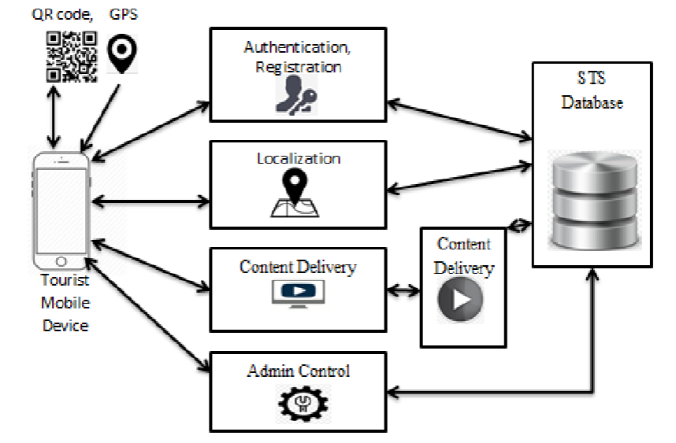

## DATA FLOW DIAGRAM:

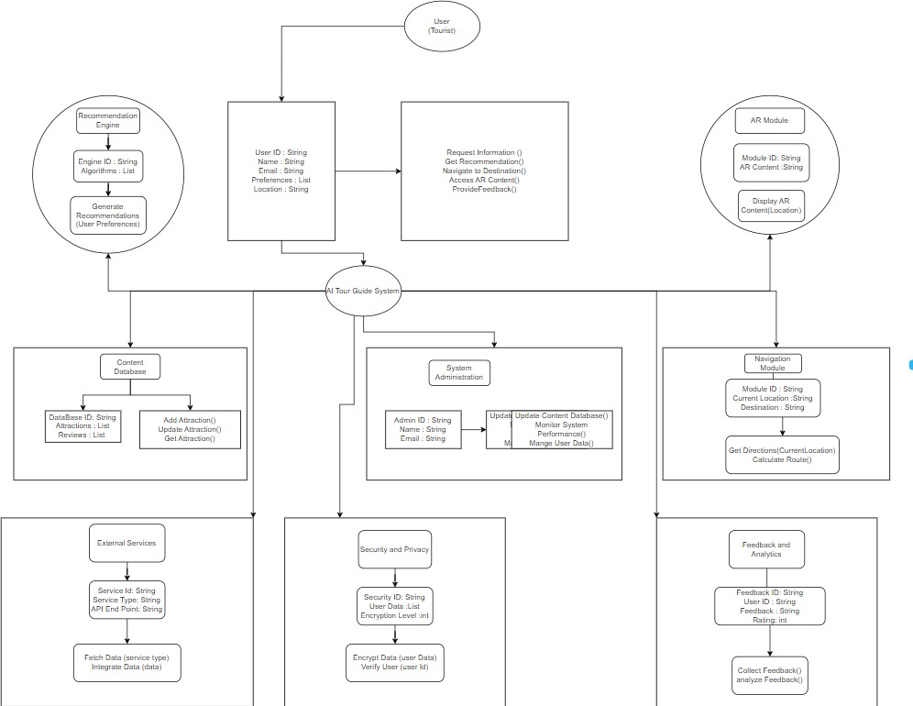

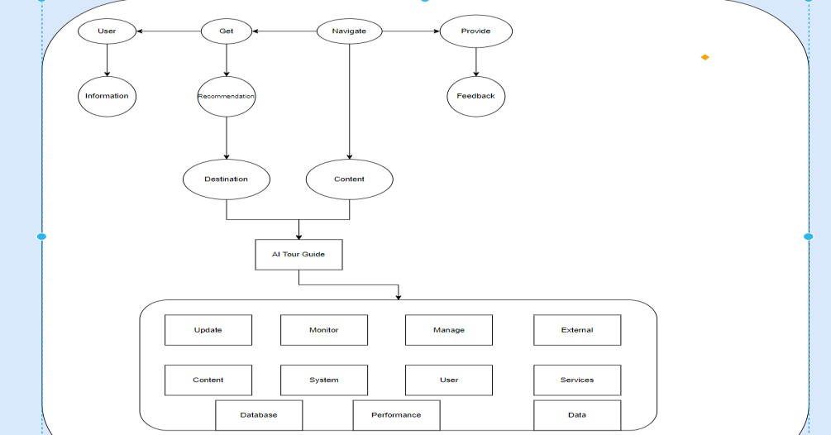

* 1. UML DIAGRAMS

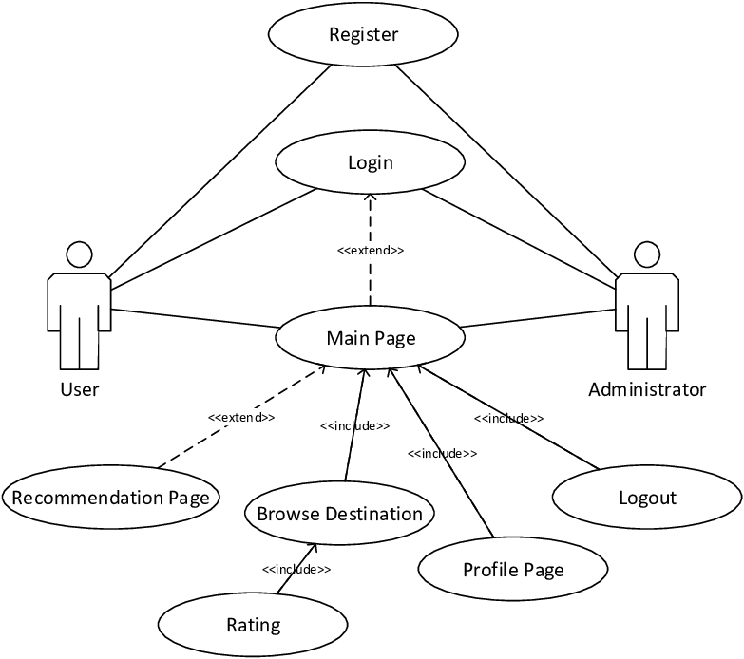

CLASS DIAGRAM:

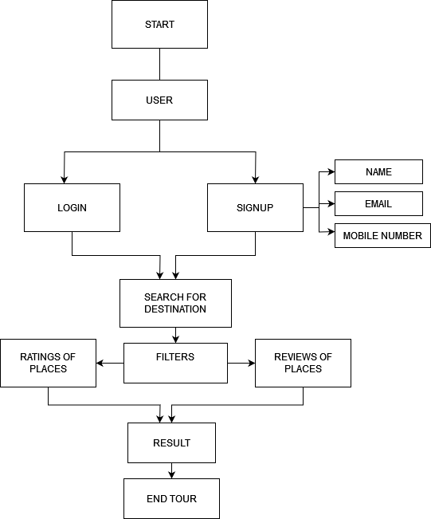

# IMPLEMENTATION

## SOURCE CODE:

### AI Tour Guide agancy

#### # HEADER

<ion-icon name="call-outline"></ion-icon> For Further Inquires :

+01 (123) 4567 90

alt = Tourly logo aria-label = Search

<ion-icon name="search"></ion-icon>

aria-label = Open Menu

<ion-icon name="menu-outline"></ion-icon>

<ion-icon name="logo-facebook"></ion-icon>

<ion-icon name="logo-twitter"></ion-icon>

<ion-icon name="logo-youtube"></ion-icon> alt = Tourly logo

aria-label = Close Menu

<ion-icon name="close-outline"></ion-icon>

home about us destination packages gallery contact us

Book Now

#### # HERO

Journey to explore world

Ac mi duis mollis. Sapiente? Scelerisque quae, penatibus? Suscipit class corporis nostra rem quos voluptatibus habitant? Fames, vivamus minim nemo enim, gravida lobortis quasi, eum.

Learn more Book now

#### # TOUR SEARCH

Search Destination* placeholder = Enter Destination

Pax Number*

placeholder = No.of People Checkin Date*

Checkout Date* Inquire now

#### # POPULAR

Uncover place Popular destination

Fusce hic augue velit wisi quibusdam pariatur, iusto primis, nec nemo, rutrum. Vestibulum cumque laudantium. Sit ornare mollitia tenetur, aptent.

alt = San miguel, italy

<ion-icon name="star"></ion-icon>

<ion-icon name="star"></ion-icon>

<ion-icon name="star"></ion-icon>

<ion-icon name="star"></ion-icon>

<ion-icon name="star"></ion-icon> Italy

San miguel

Fusce hic augue velit wisi ips quibusdam pariatur, iusto. alt = Burj khalifa, dubai

Dubai

Burj khalifa

alt = Kyoto temple, japan Japan

Kyoto temple More destintion

#### # PACKAGE

Popular Packeges Checkout Our Packeges

Fusce hic augue velit wisi quibusdam pariatur, iusto primis, nec nemo, rutrum. Vestibulum cumque laudantium. Sit ornare mollitia tenetur, aptent.

alt = Experience The Great Holiday On Beach Experience The Great Holiday On Beach

Laoreet, voluptatum nihil dolor esse quaerat mattis explicabo maiores, est aliquet porttitor! Eaque, cras, aspernatur.

<ion-icon name="time"></ion-icon>

#### 7D/6N

<ion-icon name="people"></ion-icon> pax: 10

<ion-icon name="location"></ion-icon>

Malaysia (25 reviews)

<ion-icon name="star"></ion-icon>

<ion-icon name="star"></ion-icon>

<ion-icon name="star"></ion-icon>

<ion-icon name="star"></ion-icon>

<ion-icon name="star"></ion-icon>

$750

/ per person Book Now

alt = Summer Holiday To The Oxolotan River Summer Holiday To The Oxolotan River

(20 reviews)

$520

alt = Santorini Island's Weekend Vacation Santorini Island's Weekend Vacation

(40 reviews)

$660

View All Packages

#### # GALLERY

Photo Gallery

Photo's From Travellers

Fusce hic augue velit wisi quibusdam pariatur, iusto primis, nec nemo, rutrum.

Vestibulum cumque laudantium. Sit ornare mollitia tenetur, aptent. alt = Gallery image

#### # CTA

Call To Action

Ready For Unforgatable Travel. Remember Us!

Fusce hic augue velit wisi quibusdam pariatur, iusto primis, nec nemo, rutrum. Vestibulum cumque laudantium. Sit ornare mollitia tenetur, aptent.

Contact Us !

#### # FOOTER

alt = Tourly logo

Urna ratione ante harum provident, eleifend, vulputate molestiae proin fringilla, praesentium magna conubia at perferendis, pretium, aenean aut ultrices.

Contact Us

Feel free to contact and reach us !!

<ion-icon name="call-outline"></ion-icon>

+01 (123) 4567 90

<ion-icon name="mail-outline"></ion-icon> info.tourly.com

<ion-icon name="location-outline"></ion-icon> 3146 Koontz, California

Subscribe our newsletter for more update & news !! placeholder = Enter Your Email

Subscribe

&copy; 2022 codewithsadee. All rights reserved Privacy Policy

Term & Condition

#### FAQ

# GO TO TOP

<ion-icon name="chevron-up-outline"></ion-icon>

## INPUT AND OUTPUT DESIGN

#### INPUT AND OUTPUT DESIGN

Input design involves specifying the input data that the system will accept and how users will provide this data. In the AI Tour Guide System, inputs can come from tourists, system administrators, and external services. Here are the primary input methods and data:

### User (Tourist) Inputs:

* + **User Authentication:**
    - Data: Username, Password
    - Method: Login form

### Information Request:

* + - Data: Keywords or queries about tourist spots
    - Method: Text input or voice command

### Preferences:

* + - Data: Preferred types of attractions, dietary preferences, mobility requirements
    - Method: Profile settings form

### Destination Selection:

* + - Data: Selected destination from a list of recommendations
    - Method: Dropdown menu or map selection

### Feedback:

* + - Data: Ratings, comments
    - Method: Feedback form

### System Administrator Inputs:

* + **Content Updates:**
    - Data: New or updated information about attractions
    - Method: Content management system (CMS) interface

### User Management:

* + - Data: User profiles and permissions
    - Method: Admin dashboard

### External Services Inputs:

* + **Map Data:**
    - Data: Geographic coordinates, route information
    - Method: API calls to map services

### Weather Data:

* + - Data: Current weather conditions, forecasts
    - Method: API calls to weather services

### Points of Interest Data:

* + - Data: Nearby attractions, opening hours, ratings
    - Method: API calls to external databases

**Output Design**

Output design specifies how the system will present data to users and other systems. Outputs can include responses to user queries, recommendations, navigation instructions, AR content, and feedback summaries.

### User (Tourist) Outputs:

* + **Information Display:**
    - Content: Details about requested tourist spots
    - Method: Text, images, and videos on screen

### Recommendations:

* + - Content: List of suggested attractions
    - Method: Interactive list or carousel

### Navigation Instructions:

* + - Content: Step-by-step directions, map
    - Method: Visual map, text directions, voice instructions

### AR Content:

* + - Content: Augmented reality overlays on the real-world view
    - Method: AR visual elements via camera interface

### Feedback Confirmation:

* + - Content: Acknowledgment of feedback submission
    - Method: Confirmation message on screen

### System Administrator Outputs:

* + **Content Management:**
    - Content: Status updates on content changes
    - Method: CMS interface notifications

### User Management:

* + - Content: List of user profiles, activity logs
    - Method: Admin dashboard

### External Services Outputs:

* + **Map Data Integration:**
    - Content: Map with route information
    - Method: Embedded map widget

### Weather Data Integration:

* + - Content: Current weather and forecast information
    - Method: Weather widget

### Points of Interest Integration:

* + - Content: List of nearby attractions with detail

#### SCREENSHOTS

Screen Shots:

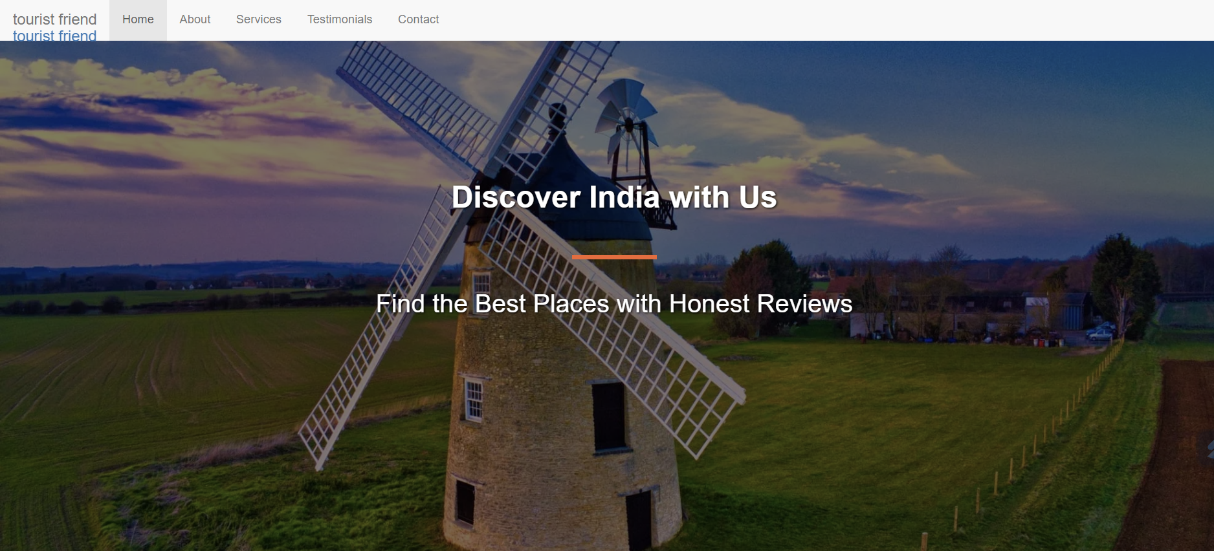

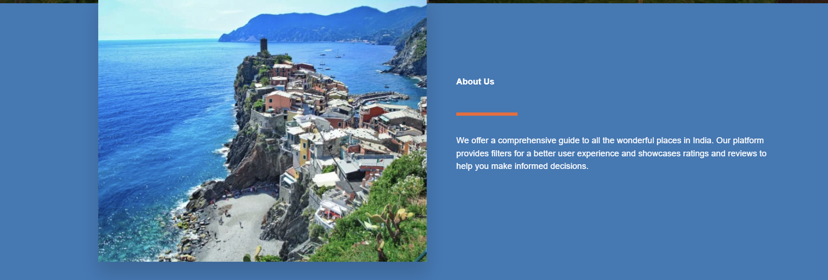

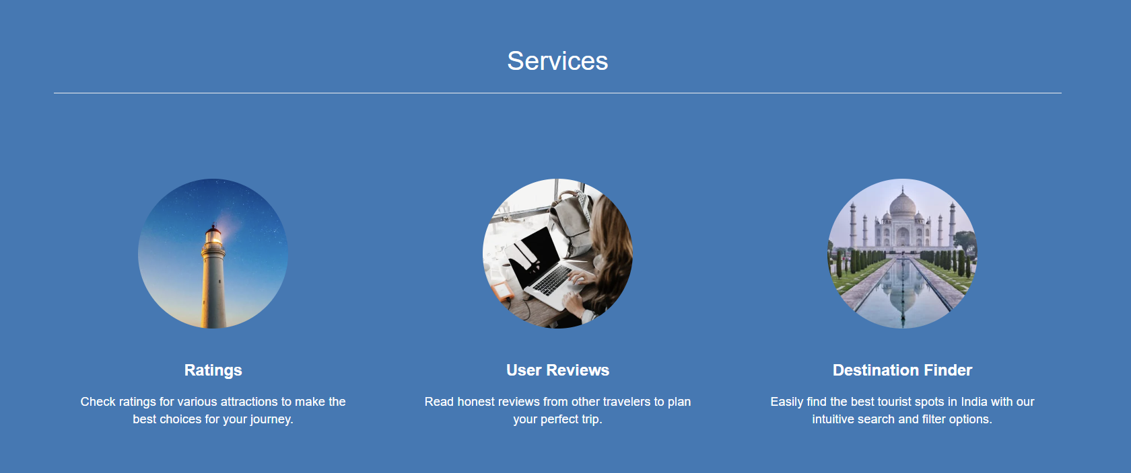

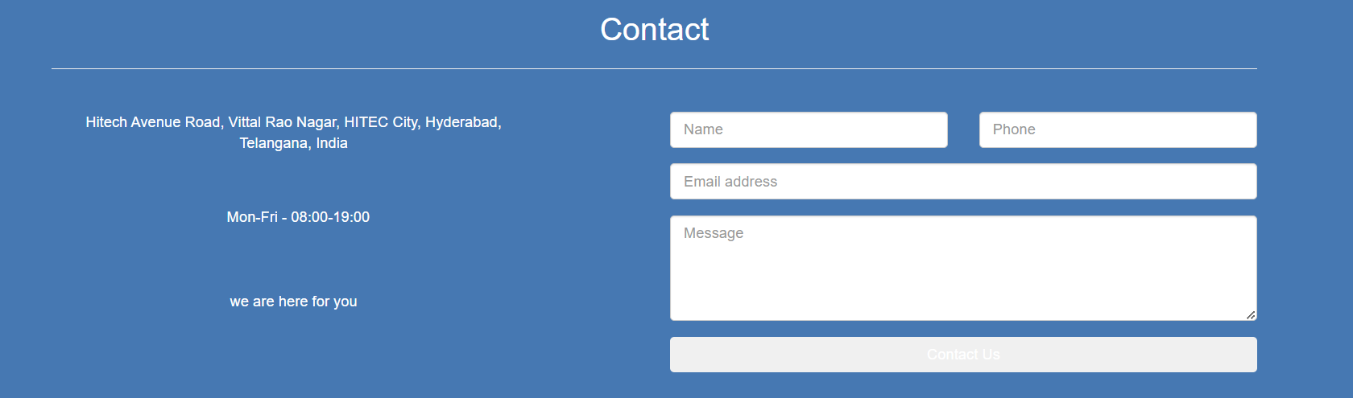

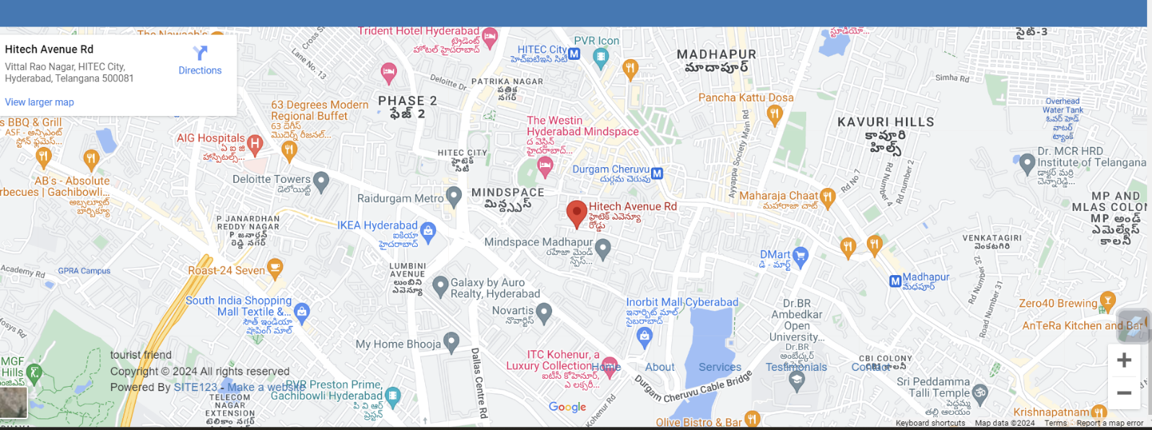

## SYSTEM TESTING

The purpose of testing is to discover errors. Testing is the process of trying to discover every conceivable fault or weakness in a work product. It provides a way to check the functionality of components, sub assemblies, assemblies and/or a finished product It is the process of exercising software with the intent of ensuring that the Software system meets its requirements and user expectations and does not fail in an unacceptable manner. There are various types of test. Each test type addresses a specific testing requirement.

#### **TYPES OF TESTS**

* + 1. **Unit testing**

Unit testing involves the design of test cases that validate that the internal program logic is functioning properly, and that program inputs produce valid outputs. All decision branches and internal code flow should be validated. It is the testing of individual software units of the application .it is done after the completion of an individual unit before integration. This is a structural testing, that relies on knowledge of its construction and is invasive. Unit tests perform basic tests at component level and test a specific business process, application, and/or system configuration. Unit tests ensure that each unique path of a business process performs accurately to the documented specifications and contains clearly defined inputs and expected results.

* + 1. **Integration testing**

Integration tests are designed to test integrated software components to determine if they actually run as one program. Testing is event driven and is more concerned with the basic outcome of screens or fields. Integration tests demonstrate that although the components were individually satisfaction, as shown by successfully unit testing, the combination of components is correct and

consistent. Integration testing is specifically aimed at exposing the problems that arise from the combination of components.

* + 1. **Functional test**

Functional tests provide systematic demonstrations that functions tested are available as specified by the business and technical requirements, system documentation, and user manuals.

Functional testing is centered on the following items:

Valid Input : identified classes of valid input must be accepted. Invalid Input : identified classes of invalid input must be rejected. Functions : identified functions must be exercised.

Output : identified classes of application outputs must be exercised.

Systems/Procedures : interfacing systems or procedures must be invoked.

Organization and preparation of functional tests is focused on requirements, key functions, or special test cases. In addition, systematic coverage pertaining to identify Business process flows; data fields, predefined processes, and successive processes must be considered for testing. Before functional testing is complete, additional tests are identified and the effective value of current tests is determined.

* + 1. **System Test**

System testing ensures that the entire integrated software system meets requirements. It tests a configuration to ensure known and predictable results. An example of system testing is the configuration oriented system integration test. System testing is based on process descriptions and flows, emphasizing pre-driven process links and integration points.

* + 1. **White Box Testing**

White Box Testing is a testing in which in which the software tester

has knowledge of the inner workings, structure and language of the software, or at least its purpose. It is purpose. It is used to test areas that cannot be reached from a black box level.

* + 1. **Black Box Testing**

Black Box Testing is testing the software without any knowledge of the inner workings, structure or language of the module being tested. Black box tests, as most other kinds of tests, must be written from a definitive source document, such as specification or requirements document, such as specification or requirements document. It is a testing in which the software under test is treated, as a black box

.You cannot “see” into it. The test provides inputs and responds to outputs without considering how the software works.

* + 1. **Unit Testing**

Unit testing is usually conducted as part of a combined code and unit test phase of the software lifecycle, although it is not uncommon for coding and unit testing to be conducted as two distinct phases.

* 1. **Test strategy and approach**

Field testing will be performed manually and functional tests will be written in detail.

* 1. **Test objectives**
* All field entries must work properly.
* Pages must be activated from the identified link.
* The entry screen, messages and responses must not be delayed.
  1. **Features to be tested**
* Verify that the entries are of the correct format
* No duplicate entries should be allowed
* All links should take the user to the correct page.
  1. **Integration Testing**

Software integration testing is the incremental integration testing of two or more integrated software components on a single platform to produce failures caused by interface defects.

The task of the integration test is to check that components or software applications,

e.g. components in a software system or – one step up – software applications at the company level – interact without error.

* 1. **Test Results**: All the test cases mentioned above passed successfully. No defects encountered.
  2. **Acceptance Testing**

User Acceptance Testing is a critical phase of any project and requires significant participation by the end user. It also ensures that the system meets the functional requirements.

* 1. **Test Results**: All the test cases mentioned above passed successfully. No defects encountered.

## CONCLUSION

The Tour Guide System revolutionizes travel experiences by integrating advanced technologies like voice recognition, augmented reality, and personalized recommendation engines. Designed for user convenience, it offers tailored content and real-time navigation, enhancing how tourists explore new destinations. The system's robust architecture ensures scalability and data security, while feedback mechanisms drive continuous improvement. With practical applications across various tourist spots, the Tour Guide System exemplifies the potential in providing dynamic, interactive, and personalized travel experiences, making it a valuable tool for both tourists and the tourism industry.

By seamlessly blending cutting-edge technologies with user-centric design, the Tour Guide System redefines how tourists engage with their surroundings. Its ability to provide personalized recommendations, intuitive navigation, and immersive augmented reality experiences elevates travel to new heights of convenience and enjoyment. With a focus on continuous enhancement and adaptability, this system not only meets the needs of modern travelers but also sets a benchmark for the future.

**14.References**

<https://www.similarweb.com/top-websites/travel-and-tourism/>

<https://tourism.gov.in/related-links/state-tourism-links>

<https://www.researchgate.net/publication/343646199_The_Use_of_Reference_in_the_Text_on_Tourism_Travel_Agency_Website>